# Spring Core - Maven

## Exercise 1: Configuring a Basic Spring Application

### Code

File: BookRepository.java  
Location: src/main/java/com/library/repository/  
  
package com.library.repository;  
  
public class BookRepository {  
 public void saveBook(String bookName) {  
 System.out.println("Book saved: " + bookName);  
 }  
}

File: BookService.java  
Location: src/main/java/com/library/service/  
  
package com.library.service;  
  
import com.library.repository.BookRepository;  
  
public class BookService {  
 private BookRepository bookRepository;  
  
 // Setter method for dependency injection  
 public void setBookRepository(BookRepository bookRepository) {  
 this.bookRepository = bookRepository;  
 }  
  
 public void addBook(String bookName) {  
 bookRepository.saveBook(bookName);  
 }  
}

File: LibraryManagementApplication.java  
Location: src/main/java/com/library/  
  
package com.library;  
  
import org.springframework.context.ApplicationContext;  
import org.springframework.context.support.ClassPathXmlApplicationContext;  
import com.library.service.BookService;  
  
public class LibraryManagementApplication {  
 public static void main(String[] args) {  
 ApplicationContext context =  
 new ClassPathXmlApplicationContext("applicationContext.xml");  
  
 BookService bookService = context.getBean("bookService", BookService.class);  
 bookService.addBook("Clean Code");  
 }  
}

File: applicationContext.xml  
Location: src/main/resources/  
  
<?xml version="1.0" encoding="UTF-8"?>  
<beans xmlns="http://www.springframework.org/schema/beans"  
 xmlns:xsi="http://www.w3.org/2001/XMLSchema-instance"  
 xsi:schemaLocation="  
 http://www.springframework.org/schema/beans  
 http://www.springframework.org/schema/beans/spring-beans.xsd">  
  
 <!-- Repository Bean -->  
 <bean id="bookRepository" class="com.library.repository.BookRepository" />  
  
 <!-- Service Bean with Setter Injection -->  
 <bean id="bookService" class="com.library.service.BookService">  
 <property name="bookRepository" ref="bookRepository" />  
 </bean>  
  
</beans>

### Output

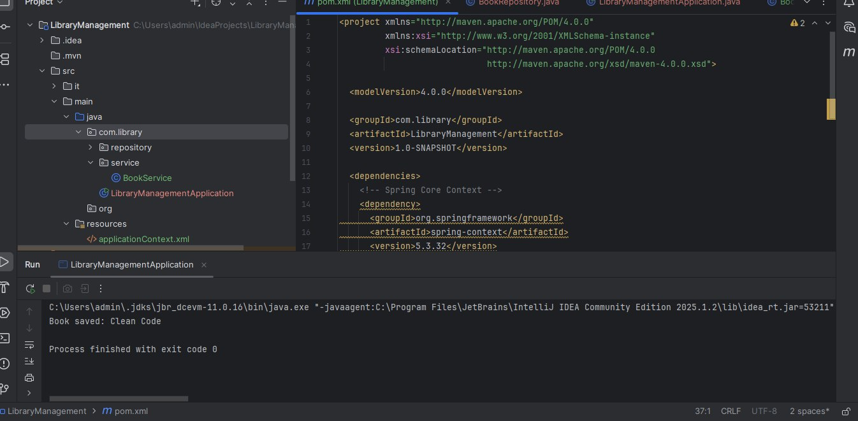

## Exercise 2: Implementing Dependency Injection

### Code

File: BookRepository.java

Location: src/main/java/com/library/repository/

package com.library.repository;

public class BookRepository {

public void saveBook(String bookName) {

System.out.println("Book saved: " + bookName);

}

}

File: BookService.java

Location: src/main/java/com/library/service/

java

CopyEdit

package com.library.service;

import com.library.repository.BookRepository;

public class BookService {

private BookRepository bookRepository;

// Setter method for dependency injection

public void setBookRepository(BookRepository bookRepository) {

this.bookRepository = bookRepository;

}

public void addBook(String bookName) {

bookRepository.saveBook(bookName);

}

}

File: LibraryManagementApplication.java

Location: src/main/java/com/library/

package com.library;

import org.springframework.context.ApplicationContext;

import org.springframework.context.support.ClassPathXmlApplicationContext;

import com.library.service.BookService;

public class LibraryManagementApplication {

public static void main(String[] args) {

ApplicationContext context =

new ClassPathXmlApplicationContext("applicationContext.xml");

BookService bookService = context.getBean("bookService", BookService.class);

bookService.addBook("Clean Code");

}

}

File: applicationContext.xml

Location: src/main/resources/

xml

CopyEdit

<?xml version="1.0" encoding="UTF-8"?>

<beans xmlns="http://www.springframework.org/schema/beans"

xmlns:xsi="http://www.w3.org/2001/XMLSchema-instance"

xsi:schemaLocation="

http://www.springframework.org/schema/beans

http://www.springframework.org/schema/beans/spring-beans.xsd">

<!-- Repository Bean -->

<bean id="bookRepository" class="com.library.repository.BookRepository" />

<!-- Service Bean with Setter Injection -->

<bean id="bookService" class="com.library.service.BookService">

<property name="bookRepository" ref="bookRepository" />

</bean>

</beans>

### Output

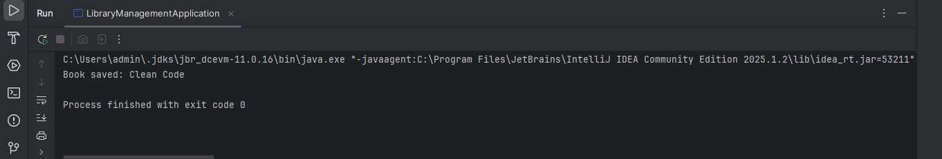

## Exercise 4: Creating and Configuring a Maven Project

### Code

1.Add the following dependencies if not already added:

<!-- Spring AOP (for future AOP exercises) -->

<dependency>

<groupId>org.springframework</groupId>

<artifactId>spring-aop</artifactId>

<version>${spring.version}</version>

</dependency>

<!-- Spring WebMVC (for future web-based components) -->

<dependency>

<groupId>org.springframework</groupId>

<artifactId>spring-webmvc</artifactId>

<version>${spring.version}</version>

</dependency>

2.Make sure they go inside the <dependencies> section.

3: Ensure the Maven Compiler Plugin is present in your <build> section:

<build>

<plugins>

<!-- Compiler Plugin to set Java version -->

<plugin>

<groupId>org.apache.maven.plugins</groupId>

<artifactId>maven-compiler-plugin</artifactId>

<version>3.8.1</version>

<configuration>

<source>${maven.compiler.source}</source>

<target>${maven.compiler.target}</target>

</configuration>

</plugin>

</plugins>

</build>

### Output

